JUDAICA | 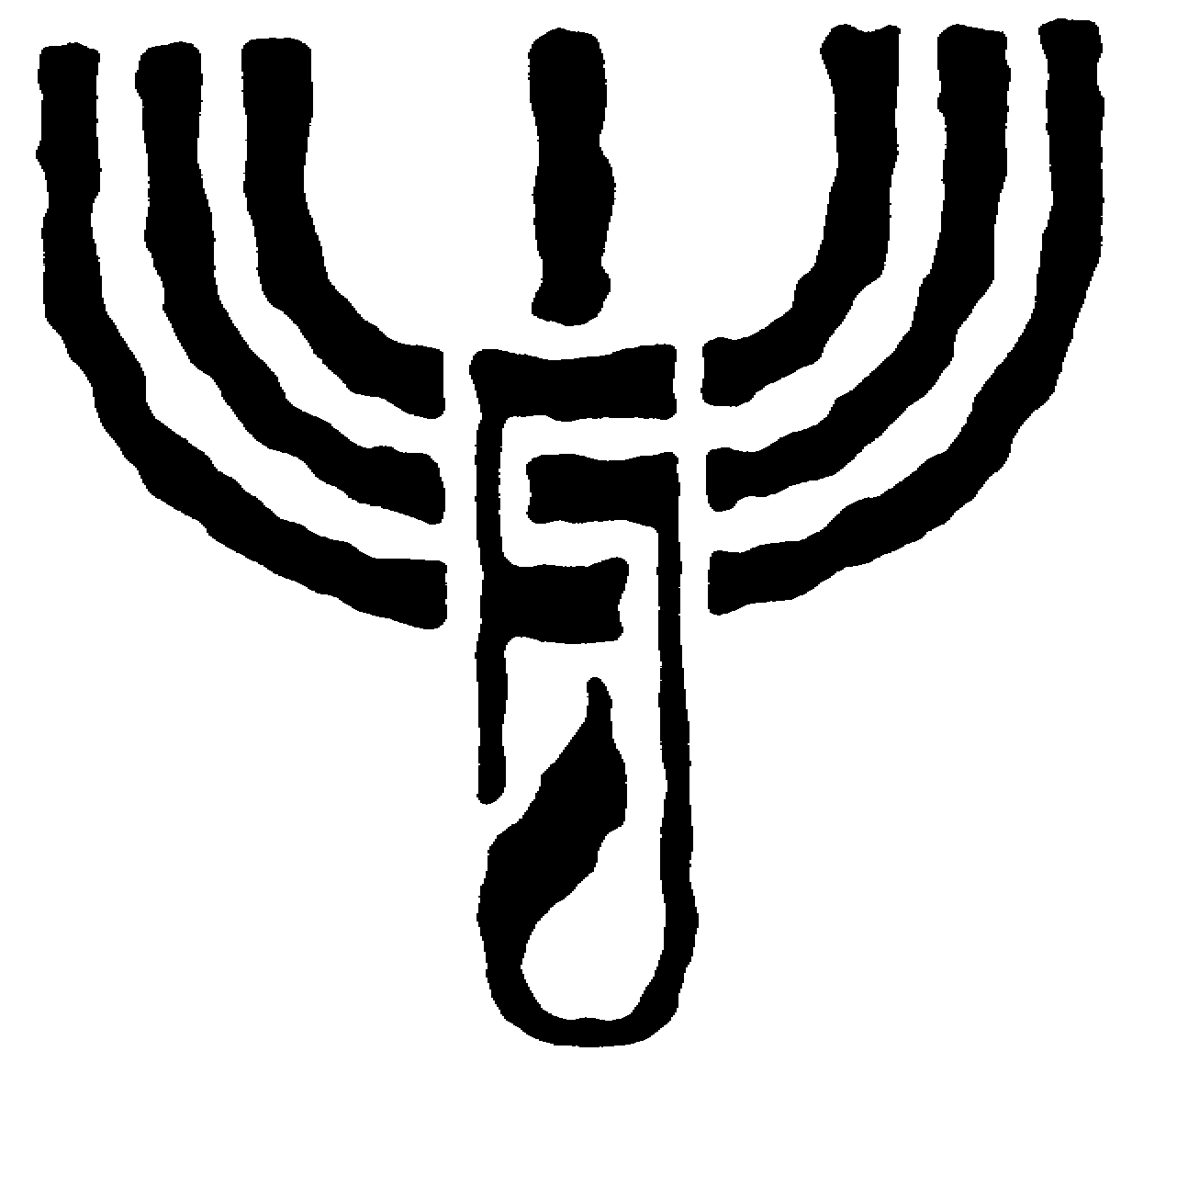 | FOUNDATION
CENTER FOR JEWISH CULTURE
P R O G R A M – M A Y 2 0 0 2

Monday, May 6th, at 6.00 p.m.
DEMOCRACY AND TOLERANCE
Meeting with Prof. Andrzej ZOLL, Poland’s Human Rights Ombudsman.

Thursday, May 9th, at 6.00 p.m.
Our Country – opening of a photographic exhibition by Alex LEVAC (Israel), presenting contemporary Israel, organized jointly with the Israeli Embassy in Poland.

Friday, May 10th, at 7.00 p.m.
GUITAR CONCERT AT THE CENTER
Lute concert by Jerzy ŻAK (Warsaw), including works by S. L. Weiss and J. S. Bach.

Saturday, May 11th, at 6.00 p.m.
Piano recital by Stefan ŁABANOWSKI (Cracow), including works by D. Scarlatti, W. A. Mozart and C. Debussy.

Monday, May 13th, at 7.00 p.m.
Chamber music concert performed by QUARTETTO D’ARCHI DI VENEZIA (Italy), organized jointly with the Italian Cultural Institute in Warsaw.

Tuesday, May 14th, at 6.00 p.m.
Secret Kahals in Latin America of Colonial Times – lecture by Prof. Jan SZEMIŃSKI (Hebrew University in Jerusalem).

Tuesday, May 14th, at 7.30 p.m.
Concert of Neapolitan songs performed by Universita della Canzone Napoletana Ensemble (Meastro Espedito De MARINO – guitar, Giuseppe PACELLI – guitar and Vincenzo ACANFORA – tenor), organized jointly with the Italian Cultural Institute in Cracow.

Wednesday, May 15th, at 6.00 p.m.
POLACY I ŻYDZI – ZDERZENIE KULTUR
Film showing: Kutno, Part One by Agnieszka ARNOLD and meeting with the film director moderated by Piotr LITKA.

Thursday, May 16th, at 6.00 p.m.
JERUSALEM DAY
Film showing: Jerusalem presenting the multicultural character of Jerusalem, and meeting with Michał NEKANDA-TREPKA.

Friday, May 17th, at 6.00 p.m.
Paintings – opening of an exhibition by Barbara KONIC (Warsaw).

Monday, May 20th, at 6.00 p.m.
POLES AND JEWS – ONCE AGAIN?
Meeting with Prof. Stefan NIESIOŁOWSKI, moderated by Prof. Jan WOLEŃSKI.

Wednesday, May 22nd, at 6.00 p.m.
POLAND’S INTEGRATION
WITH THE EUROPEAN UNION
Poland in the EU – who needs it? – meeting with Andrzej JONAS, Editor-in-Chief of The Warsaw Voice weekly.

Thursday, May 23rd, at 6.00 p.m.
BIBLE AND HISTORY
Hebrew Bible and Christian Bible. Presentation of the Vatican Biblical Commission Document of 2001 – lecture by Rev. Prof. Józef CHMIEL (Pontifical Theological Academy in Cracow)

Saturday, May 25th, at 10.00 a.m.
Post card auction organized by the RARA AVIS Antiquarian Bookshop in Cracow.

CENTER FOR JEWISH CULTURE, MEISELSA STREET 17, 31-058 CRACOW, POLAND,
TEL. ++48 12 / 430 64 49, 430 64 52, FAX ++48 12 / 430 64 97, e-mail: info1@judaica.pl www.judaica.pl

